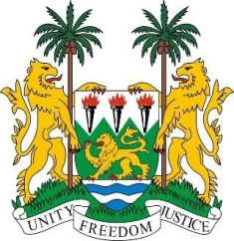
SIERRA LEONE

27th Session of the UPR

THE KINGDOM OF THE NETHERLANDS

10 May 2017

Mr President,

Sierra Leone welcomes the delegation from the Netherlands and thanks them for their presentation.

My delegation notes with interest the adoption in 2014 of the Action Plans on Children’s Rights, as well as the ongoing efforts to combat child trafficking and child sex tourism. Sierra Leone congratulates the Netherlands for reaching 30% women representation in Parliament.

We note the steps being taken to address discrimination, including the municipal anti-discrimination bureaux and the launching of the vision for addressing the activities of the Decade of People of African Descent - the first European Country to do so.

Sierra Leone encourages the Netherlands to continue to actively work to address discrimination against minorities and migrants on the basis of race and religion, and to convict perpetrators of hate crimes.

Furthermore, the Netherlands has consistently contributed to the OHCHR since 2012 and has also supported various UN (Trust Fund) initiatives since that time. Sierra Leone would like to appeal to Netherlands to consider upholding these, as well as the level of its ODA at 0.7% of GNI as it has done in the past.

Recommendations:

- Withdraw its reservations to various articles of the CRC.
- Investigate and prosecute racist and xenophobic discourse, as well as incitement to hatred as perpetuated in the media and on the internet by extremist political parties and politicians.
- Revise the Bosman Act in order to ensure that all nationals, regardless of their birth place are not unduly excluded from living and working in the Netherlands.

Finally, Sierra Leone wishes the Kingdom of the Netherlands every success in this third review cycle.

Thank you, Mr President.

